

OPEN Project

Client

1e Iteration



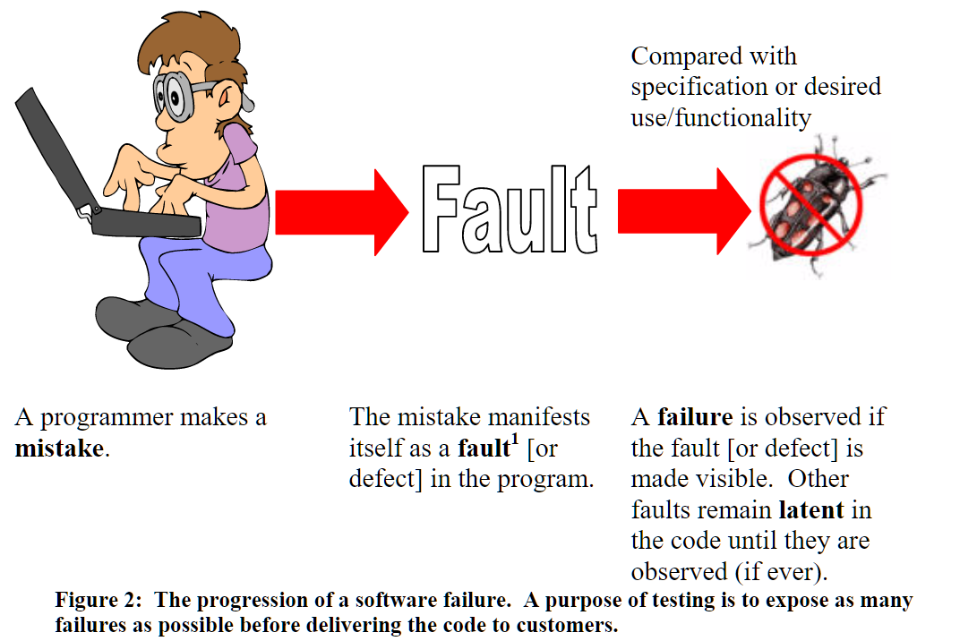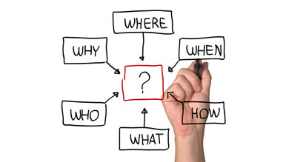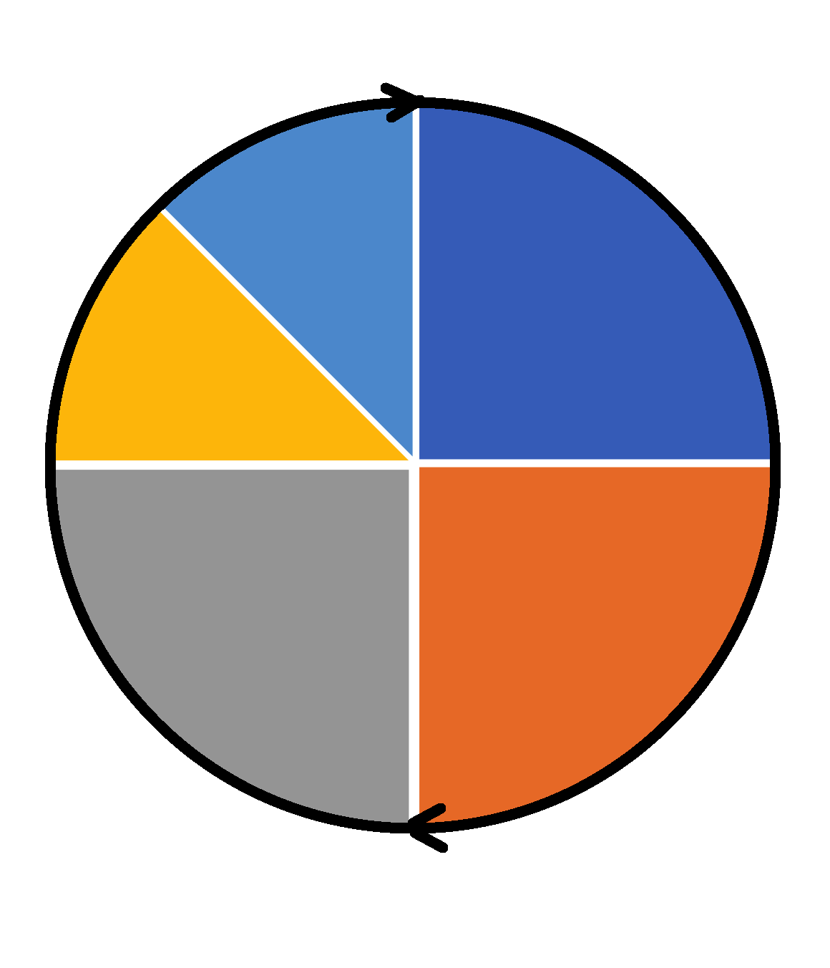

**Monitoring**

**Exit criteria??**

=>when to stop testing

->at any level

Look at:

+Requirements covered

+Residual risks (like defects not fixed?)

+Cost-budget

+Schedule

Test-process

**Planning**

+>**WHO is your Contact???**

+>Structure work

->What done/used by team

(tools, metrics…)

->What test types, Need automation?

->Priorities, Public, platform, risks & goals

->In Dialogue with customer/team

+>**Documentation**

->**Oracle**

->**Functional Requirements**

+>**environment**

**+>Testplan!!!**

**FIRST IMPRESSIONS & BE NEUTRAL**

**!!Ask questions!!!!**

**!!WATCH OUT WITH ASSUMPTIONS!!**

IT-process

**Acceptance testing**

=>testcases written by **customer**

->can refuse product delivery if they don’t pass.

=>satisfies **acceptance criteria**?

->user

->operational

->Contract- and regulations

->a & b-testing

**Test Design**

**Coverage**=>What (not) to test

->priorities

Use **test strategies** (structured approach)

=>**Functional** test case creation

**Actual results**

**Reporting**

**Logging** Fail/Pass, Bug/Recommendations, …

Make **screenshots/recording** of bugs

Test rapport=>1min readable

**Incident reporting**

**Optimisation of process**

-Collected **metrics**

-Improvements to test process??

+>**1 change** (**max 2) /iteration**

Bugs

New Features

**Preparation**

Version control=>test cases reusable?

Create **Logical** Test cases

Create/collect **Test data**

**Set up environments**

**Test Execution**

+>in order of **priority**

**Testing**

**Development**

**LIVE**

**Analyse**

**Acceptation**